Amazon Business | End User FAQ Library

Getting Started

Getting Started
How do I create my Amazon Business account?
Get access to Amazon Business by emailing the PCard Help Desk to request an invitation to join the CSU Amazon Business. The first time you access Amazon Business you will be prompted set up your account.

Use your @colostate.edu email address and create a password.
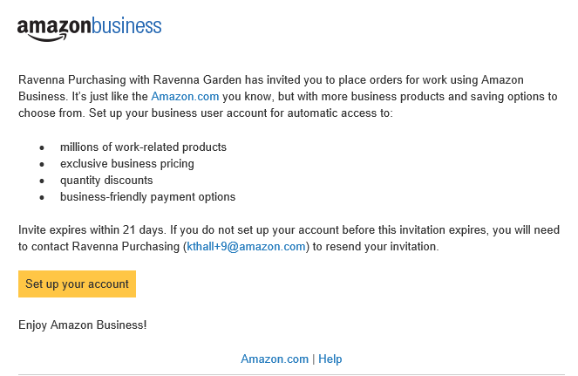
What if I haven’t received an invitation?
Be sure to check your spam or deleted email folders. The registration email is sent directly from Amazon.com (no-reply@amazon.com). If you still cannot locate the email, contact Kellie Rainwater to have it resent.

How do I register as part of the Colorado State University Amazon Business account?
Please read the following instructions prior to accessing Amazon Business. This will ensure your account is set up before making purchases.

Scenario 1
I have never used my @colostate.edu email address on Amazon.com
The first time you access Amazon Business, you will be prompted to set up an Amazon Business account. Use your @colostate.edu email address and enter a password. (Please note: your password does not need to be the same as other internal systems).

Scenario 2
I already use my @colostate.edu email address to make PERSONAL purchases on Amazon.com
If your @colostate.edu email address is already associated with an Amazon.com account, you will have the option to split off and transfer any purchase history to a separate account. You will be prompted to enter a new, personal, email address (e.g. gmail.com or hotmail.com) that is NOT tied to another Amazon account.

Scenario 3
I already use my @colostate.edu email address to make BUSINESS purchases on Amazon.com
If your @colostate.edu email address is already associated with an Amazon.com account, you will have the option to merge your existing account and transfer any purchase history and pending orders to the central business account. You will be prompted to enter in your same password, and in small blue writing please click “I want to convert my existing account and transfer my order history and info to my business account” when prompted to merge your account.

What if I previously used my @colostate.edu email address to register for a verified Amazon Business account?
If you previously used your @colostate.edu email address to register for an Amazon Business account, you will need to de-register that account. Your information and order history will still exist and will follow the user to the next Amazon Business account if you choose to convert your existing account when accepting the invitation. All previous, stand-alone, Amazon Business accounts will be consolidated under the new, centralized account.
How do I deregister my account?
- Log into your Business Account
- Download an order history report for the past 6-12 months
- Click the following link to deregister your existing account: https://amazon.com/gp/b2b/manage/deregister
NOTE: The terminology on this screen can be confusing. Rest assured your order history will not be lost, your account will be converted back to an Amazon consumer, allowing you to join the central Amazon Business account.
Once you are done, please email your account admin, Kellie Rainwater , to request an invitation to the central business account.

I tried to deregister my account but it says “I don’t have permissions to close this account.” How should I proceed?
The reason you do not have permissions to close your account is because you are not the administrator of the account you are tied to. Please reach out to the administrator on the existing account and have them remove you. If you are unsure of who your account administrator is, please contact Customer Service at 888-281-3847.

When I access Amazon Business for the first time, I am prompted to log in with a password. I do not know my login information.
You are asked to enter a password because you have an existing account with Amazon with your @colostate.edu email address. If you cannot remember the password, please select the “forgot password” button to reset. If you are still having trouble resetting the password, please call Amazon Business Customer Service at 888-281-3847 and ask them to reset it for you. Once your password has been reset, you will either want to follow Scenario 2 to separate out your order history or Scenario 3 to merge your existing account into.

Can I use the new Amazon Business account for PERSONAL use?
No. The central Amazon Business Account must be used for business purchases only, in accordance with our purchasing policies. The purchasing team will have access to all purchasing history made through the Amazon Business account.

I forgot my password for my Business account and am unable to reset the password.
Please contact Amazon Business Customer Service by clicking Contact Us (preferred method) or at 888-281-3847.

How do I contact Amazon Business Customer Service?
Amazon Business Customer Service can be reached by clicking Contact Us (preferred method) from within your account or at 888-281-3847.

Payment Method
What form of payment should I use to make Amazon Business purchases?
Enter your purchasing card information. This can be entered ahead of time in ‘Your Account’ or during the checkout process. Payment instruments are visible to your account administrator and can be audited.

Tax Exemption
I was charged sales tax on my order even though my Amazon Business account is setup for tax exempt purchasing. How do I get refund?
Because Amazon provides a marketplace made up of millions of sellers, there are instances when sellers may still charge tax on a tax exempt purchses. Contact the Seller directly to request the refund.
- From within your account, navigate to “Your Orders”
- Find the item that was charged tax and click “Contact the Seller”
- Enter subject as “Tax Exemption Refund Request”
- Include the order number and amount charged

If you have issues contacting the seller, or other order related questions, please contact the Business Customer Service team HERE or directly by phone at 888.281.3847.

Orders
How will I know when I will receive an order?
The person who placed the order will receive a confirmation email that will state the items estimated delivery date and shipping speed.

How do I see the orders I placed after joining the Amazon Business Account?
From within your account, navigate to Your Orders. The default view will display all orders “Paid Fo By You”. If your organization is utilizing a central payment method (i.e. not your individual purchasing card), select “View All Orders” from the drop-down menu.

How do I track my Amazon Business delivery?
You can view real-time delivery details for all pending orders, including estimated delivery date and carrier information. From within your account, navigate to Your Orders > Track Package.

Delivery
What address should I be using?
You are responsible for adding your site address the first time you check out, or you can add it to your account settings prior to the first time you check out. Go to Your Account > Your Addresses > Add Address > Enter in Site name in “Full
Name” section. When you check out, you will be able to add a user name, or department name, so that it is clearly labeled on the shipping label.

My order will not process, what should I do?
If your order will not go through please validate that your purchasing card is not expired and your billing address is correct. Check with your account administrator regarding any purchasing card transaction limits.

Returns
How can I return or cancel an item?
To return an item, access your Amazon Business account. Navigate to “Your Orders” to find the item(s) you want to return. From Your Orders:
- Select Return or Replace items
- Choose a reason for return
- Print label and authorization
- Prepare package and return label
Items shipped and sold by Amazon.com can be returned within 30 days of receipt of shipment. Return policies, and timeframes, can vary if purchase was made from a 3rd party seller.

Prime
What items are eligible for Business Prime Shipping?
Millions of products are eligible for Business Prime Shipping and are designated with the Prime logo. You’ll be charged applicable shipping fees for items not eligible for Business Prime Shipping (Learn more).

Are there other benefits besides Free Two-Day Shipping with Business Prime?
Besides Free Two-Day Shipping on millions of eligible items, Business Prime Shipping provides all employees on your business account access to Prime Early Access and Prime Day deals. Business Prime Shipping currently does not include consumer programs such as Prime Pantry, Fresh, Music, or Video.

What should I do if I purchased an individual Prime Membership with my purchasing card?
Our Amazon Business account has Business Prime Shipping that covers all users. If you have added an Amazon Prime membership to your existing CSU.edu account, please contact the PCard Help Desk for assistance.

Can I use Business Prime Shipping benefits on my personal Amazon.com account, too?
No. Business Prime Shipping benefits can only be used with your business account

What do I do if I bought a Prime Membership with personal funds on my Amazon account?
If you were using your business email for your personal Amazon account and purchased a Prime Membership with personal funds, you will have the option once you register to split off your personal order history and Prime Membership to a personal account.

Other Amazon Programs

Amazon Smile
Can I use Amazon Smile to donate to charity while making purchases on Amazon Business?
Yes, on your first visit to Amazon Smile (https://smile.amazon.com/), you are prompted to select a charitable organization. Select Colorado State University Foundation from the list of eligible organizations. Every item available for purchase on Amazon Business is also available on Amazon Smile (https://smile.amazon.com/) at the same price. You will see eligible products marked "Eligible for Amazon Smile donation" on their product detail pages.

Customer Service and Feedback
How do I contact Amazon Business Customer Service?
Amazon Business Customer Service can be reached by clicking Contact Us (preferred method) from within your Amazon Business account. Or, by phone at 888-281-3847 (you will be required to provide additional information to validate your account by phone). Please use this team for anything relating to an order, transaction, shipment, and general Amazon related inquiries as well.

